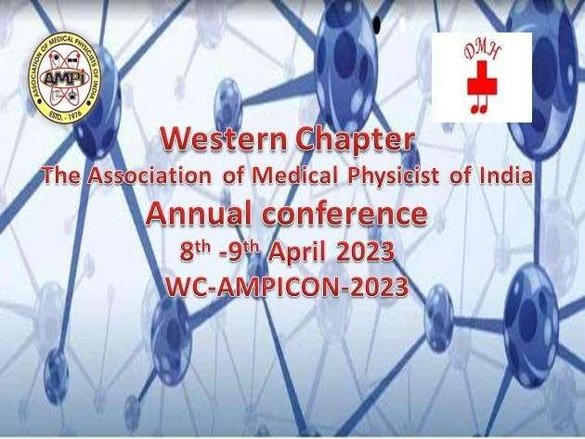
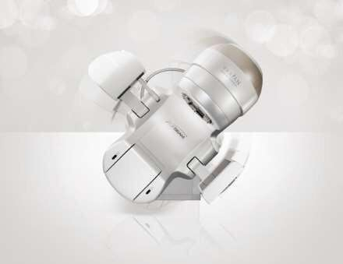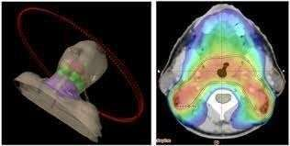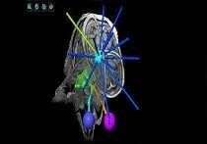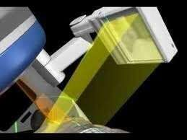

Overcoming the challenges of Medical Physicist in current practice

Organised by
Department of Radiation Oncology and Medical Physics Deenanath Mangeshkar Hospital and Research Center, Pune.

Dear Colleagues,

On behalf of the Organizing Committee, I am extremely delighted to welcome you to Annual Conference of Western Chapter of Association of Medical Physicists of India (WC-AMPICON-2023) to be hosted by Deenanath Mangeshkar Hospital and Research center, Pune and Western Chapter of Association of Medical Physicists of India (WC-AMPI) at Pune, on 8th & 9th April 2023.
The theme of conference is “Overcoming the challenges of Medical Physicist
in current practice”.
Every day new technologies are emerging in radiation therapy one need to adapt the technology and acquire the skill in upcoming technology. The conference offers scientific, educational and professional presentations spanning the range of current Medical Physics challenges.

This conference aims to explore the information regarding the AAPM protocols, planning related challenges in IMRT, SBRT, SRS, SRT Respiratory Gating planning, Patient specific QA, current innovations in Radiotherapy and Vendor presentation of latest product in Radiotherapy.

We believe that this conference will be an important and meaningful event in bringing together professionals and in contributing to a better understanding of "Today’s requirement of Medical Physicist in Radiation Therapy”.

It gives us immense pleasure to extend to you this invitation on behalf of Western Chapter of Association of Medical Physicists of India and Deenanath Mangeshkar Hospital, Pune for Annual meeting on 8th & 9th April 2023.

The organizing Committee solicits your cooperation and participation to make it a memorable event. We look forward to welcome you at Pune.

Dr. D.S. Kelkar
Medical Director, DMH

Dr. S. D. Sharma
President, AMPI

Ms. Kalpana Thakur
Chairperson, WC-AMPI

Mr. Rahul Phansekar
Secretary, WC-AMPI
ORGANISINGCOMMITTEE
Dr. Sonali Pingley Dr Shailesh Shende
Organising Chairman
Mr.Kuldip G Jadhav
Organising Secretary

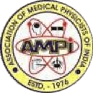

Regards,

Kuldip G Jadhav
(Organising Secretary)
Mr. Amod Vaidya
Joint Organising Secretary

Mr. Praveen Kumar S
Joint Organising Secretary

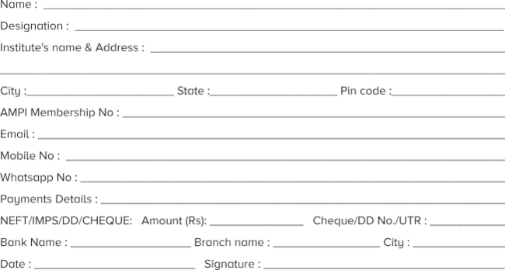
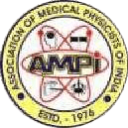
Annual conference of Western Chapter Association of Medical Physicists of India
Advancements in Radiation therapy
8th & 9st APRIL 2023
LAST DATE OF REGISTRATION: - 25 March 2023

Please send us a copy of the transaction slip (in case of online transfer) along with scanned registration form through email to amodvaidya26@gmail.com - Contact: 9923224450

Note: Registration Fees Rs. 1000/- Spot Registration fees Rs.2500 /-

Up to 5/4/2023- Registration Fees Rs 1500/-

AMPI Bank Details as below:
Saving bank Account, Bank Name: SBI, Branch Name: Anushakti Nagar.
Account Name: WESTERNCHAPTER OF AMPI
Account No. : 31792905767 IFSC CODE : SBIN0010124 MICR CODE : 400002168

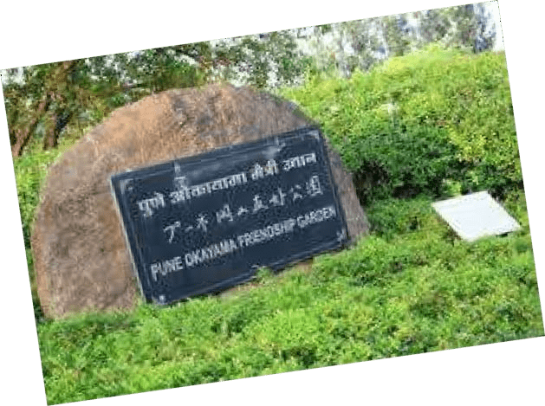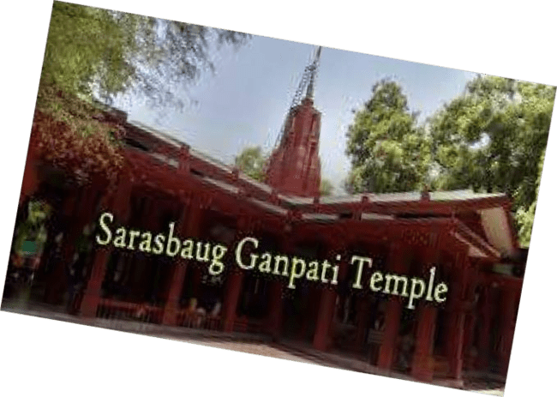

Deenanath Mangeshkar Hospital and Research Center, Pune

